John Douglas Woodward Conversation and Book Signing at Shrine Mont

October 27 @ 2:00 pm - 3:30 pm
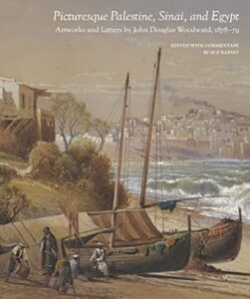
Picturesque Palestine, Sinai and Egypt: Artwork and Letters by John Douglas Woodward is a beautiful and engaging presentation of drawings and letters by John Douglas Woodward (1846–1924), a prominent American artist/illustrator during the 1870s and 1880s. He was on assignment for New York publisher D. Appleton and Co. to make on-the-spot drawings for illustrations for Picturesque Palestine, Sinai and Egypt (1881–1883), which has been called the most important book of illustrations of the region of its time. Some 200 of his compositions appeared in the book as wood engravings, the least expensive mass media of the time, while he contributed the art for 13 steel engravings.
Join the author Sue Rainey and discuss her most recent book on John Douglas Woodward’s work. Sue will hold a brief talk about Woodward and the book and be glad to sign your copy.
Contact Shrine Mont (540.856.2141) if you’d like to join us for our famous Fried Chicken Lunch at 12:30 pm.

